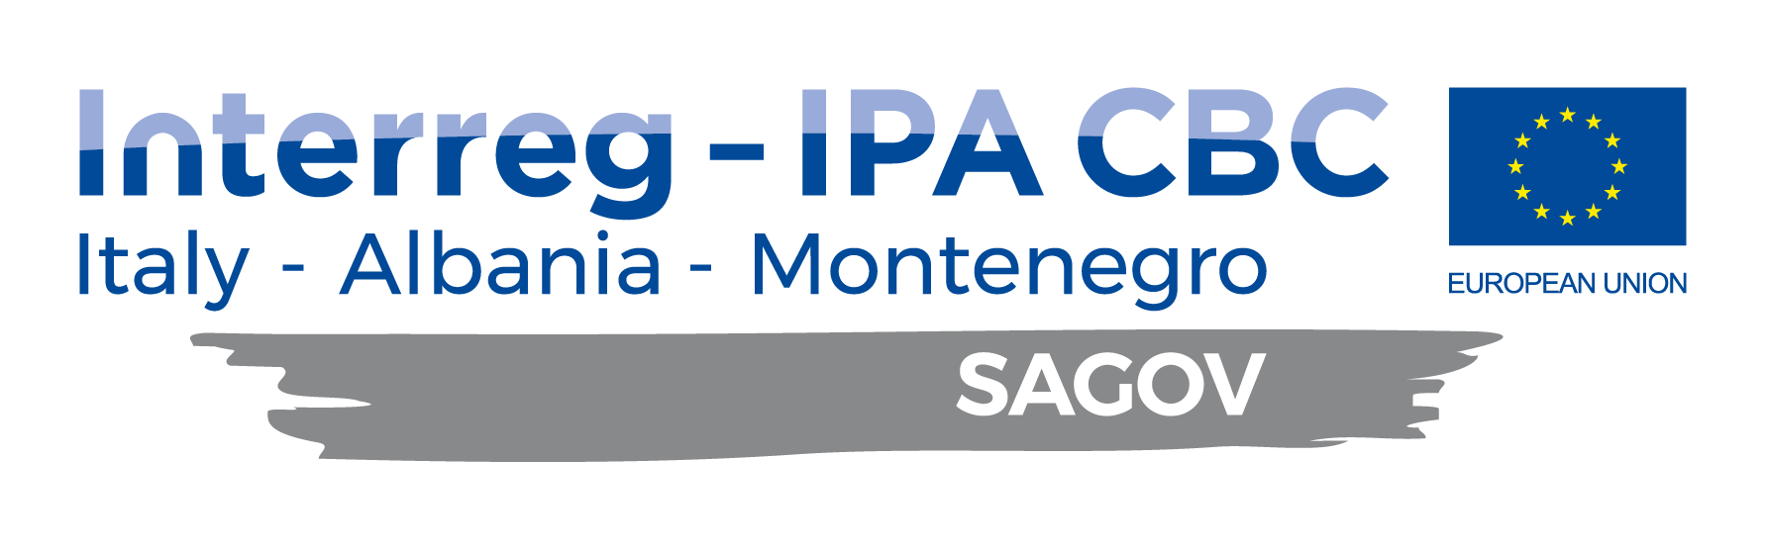

FINAL CONFERENCE
"South Adriatic Connectivity”

26th February 2021, 12:00 - 14:00, ZOOM
(Work language of the conference is English)

AGENDA

11:45 – 12:00 Room is opened for participants

12:00 - 12:15 Welcome Notes

- Mr. Momčilo Radulović, President of the European Movement in Montenegro

12:15 – 13:00 PANEL 1: CONNECTIVITY IN SOUTH ADRIATIC

- Mr. Đorđe Otašević, independent advisor at Ministry of Capital Investments of Montenegro
- Mr. Ardian Hackaj, Cooperation and Development Institute
- Representative of Ministry of Economy, Trade and Energy of Albania, (tbc.)

Moderator: Mr. Momčilo Radulović

13:05 – 13:45 PANEL 2: VTMIS Control of the Maritime Board and Zones

- Mr. Marco Tomaino, Italian Coast Guard
- Mr. Nexhat Kapidani, Administration for Maritime Safety and Port Management of Montenegro
- Representative of Port of Durres (tbc.)

13:45 – 14:00 Discussion

